Day 4 Python randomization and python lists

<https://www.udemy.com/course/100-days-of-code/learn/lecture/18029111#overview>

Rock Paper Scissors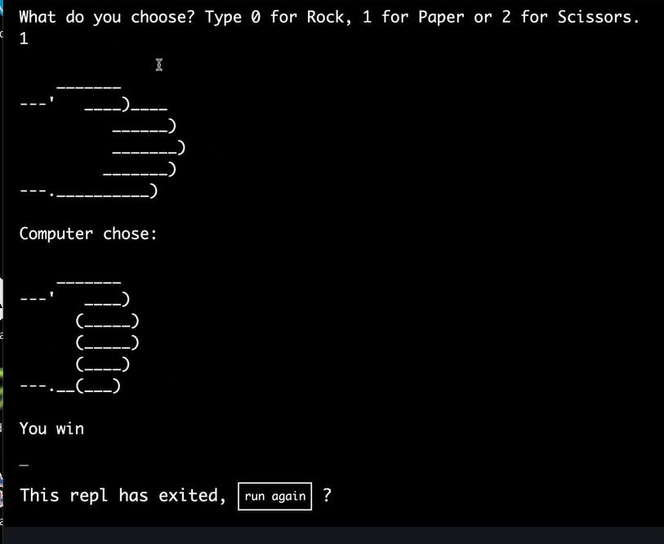

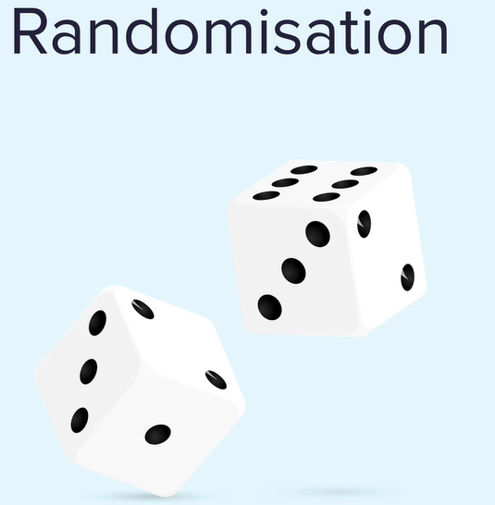

Makes games fun – but computers are Deterministic

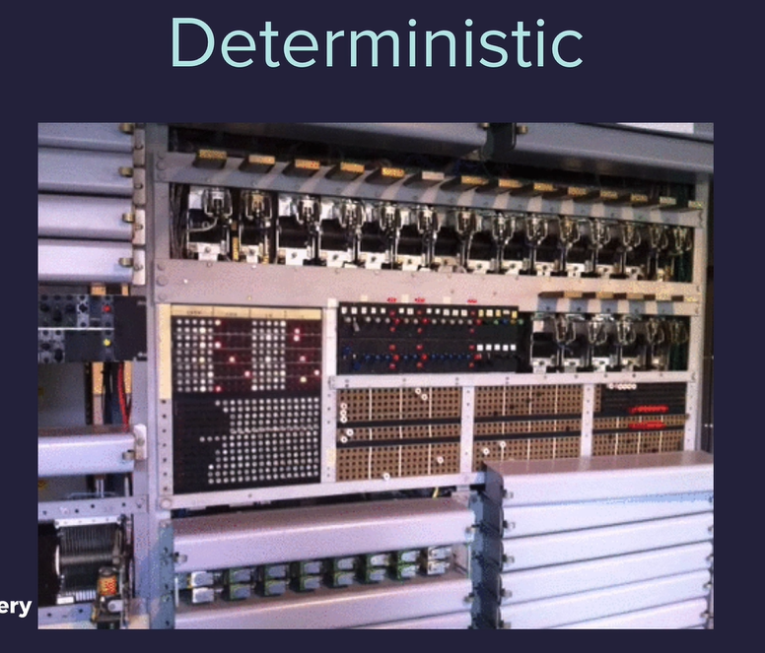

Python uses the Mersenne Twister for psudo randomization

https://en.wikipedia.org/wiki/Mersenne_Twister

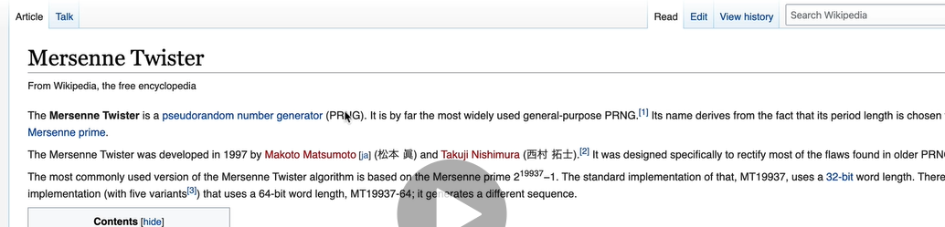

Khan Academy Video

<https://www.khanacademy.org/computing/computer-science/cryptography/crypt/v/random-vs-pseudorandom-number-generators>

Google algorithm is very complex

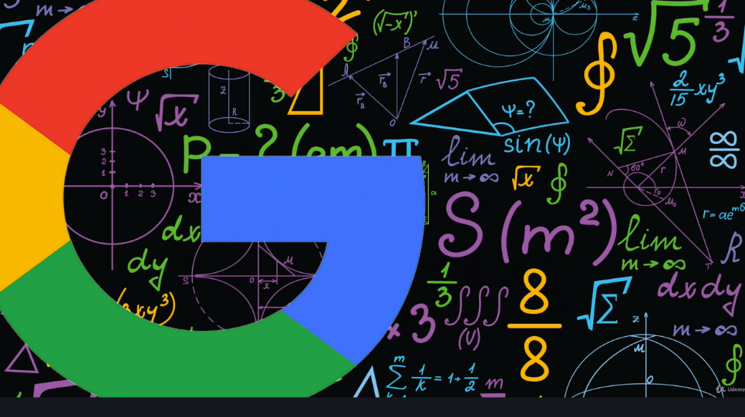

Ask Python .com random module

<https://www.askpython.com/python-modules/python-random-module-generate-random-numbers-sequences>

Module are reusable bits of code so that we do not have to re invent the wheel

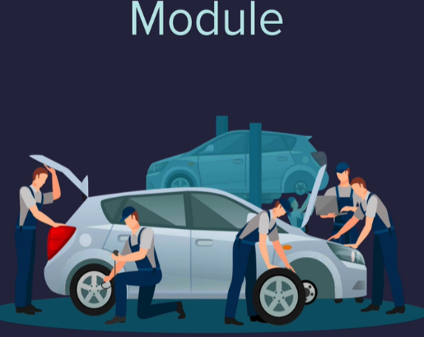

Random module was created by the python team 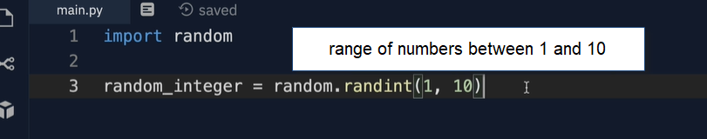

We can create our own “module”

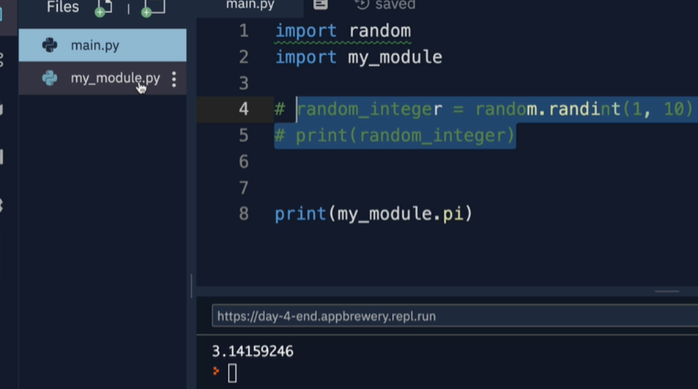

Random floating point numbers



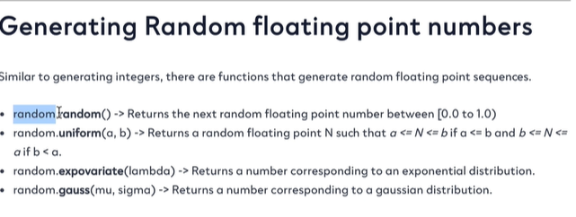

Heads or tails

Seed can be any number of things , decay pattern of something that is decomposing

<https://www.nytimes.com/interactive/2018/05/03/magazine/money-issue-iowa-lottery-fraud-mystery.html>

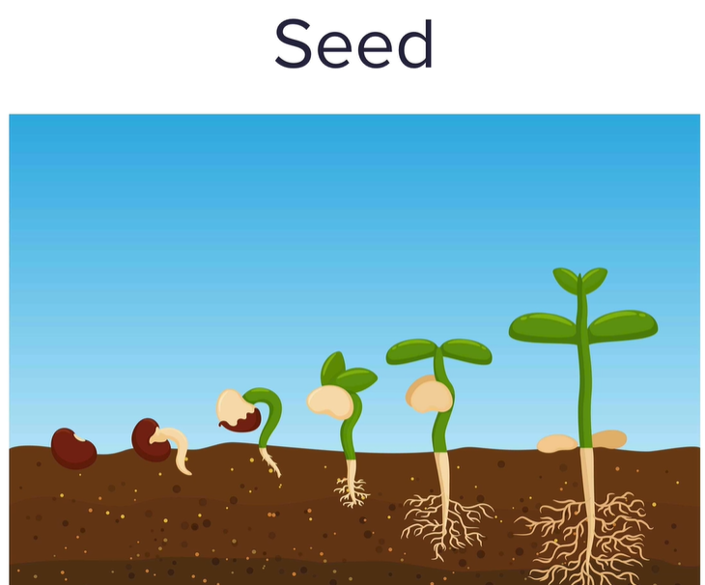

The default seed for the python random module is the time stamp but we can change that…

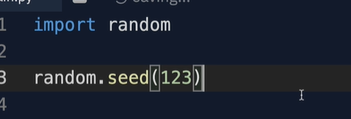

If you specify the same seed, the same random number will be generated.

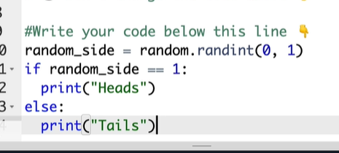

**Python lists- a data structure used to store data in python**

Store group of data that is connected in some way

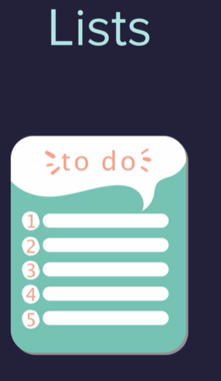

Like the united states

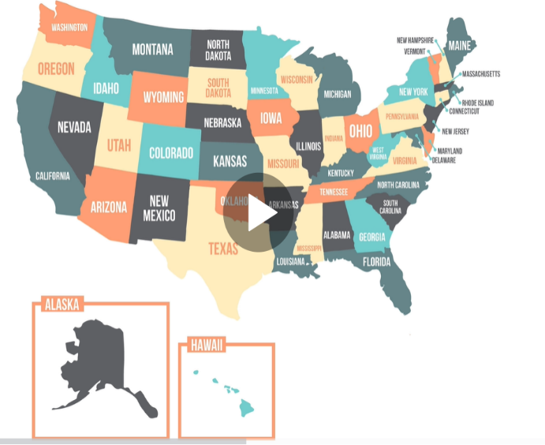

Or order of data like the order of people in a virtual que

s

<https://www.w3schools.com/python/python_lists.asp>

What Is a List in Python?

A **list** is a data structure that's built into Python and holds a collection of items. Lists have a number of important characteristics:

* List items are enclosed in square brackets, like this *[item1, item2, item3]*.
* Lists are **ordered** – i.e. the items in the list appear in a specific order. This enables us to use an index to access to any item.
* Lists are **mutable**, which means you can add or remove items after a list's creation.
* List elements **do not need to be unique**. Item duplication is possible, as each element has its own distinct place and can be accessed separately through the index.
* Elements can be of **different data types**: you can combine strings, integers, and objects in the same list.

List data structure

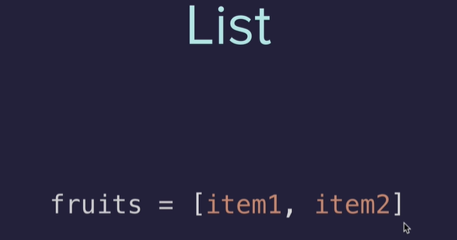

Things you can do with lists

<https://docs.python.org/3/tutorial/datastructures.html>

like arrays start at 0

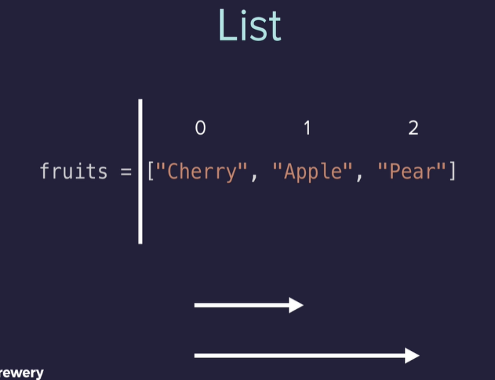

**Remember what is possible vs memorizing**

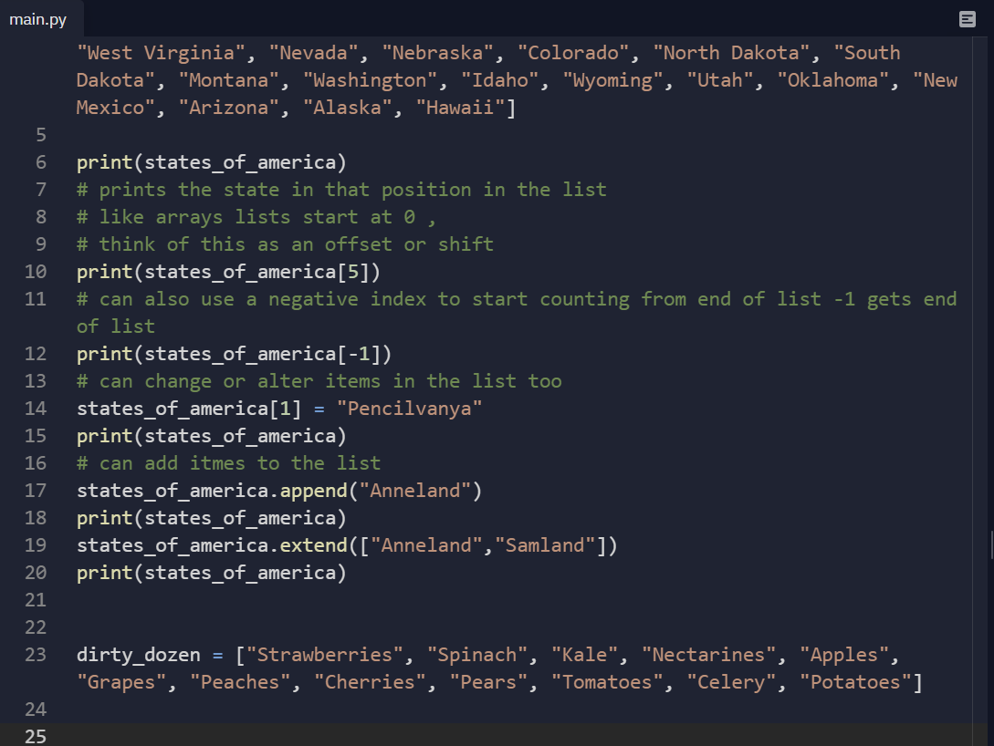

Banker Roulette exercise

str.split - use to split a string based on some type of divider

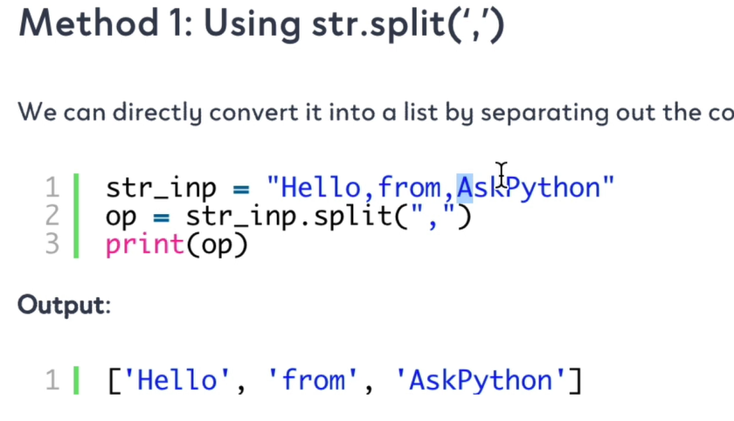

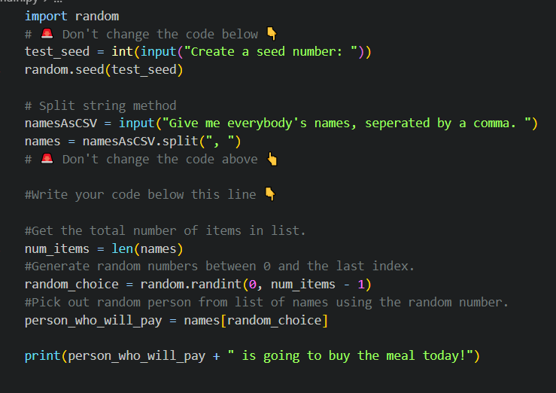

Python also has a way to do this built in

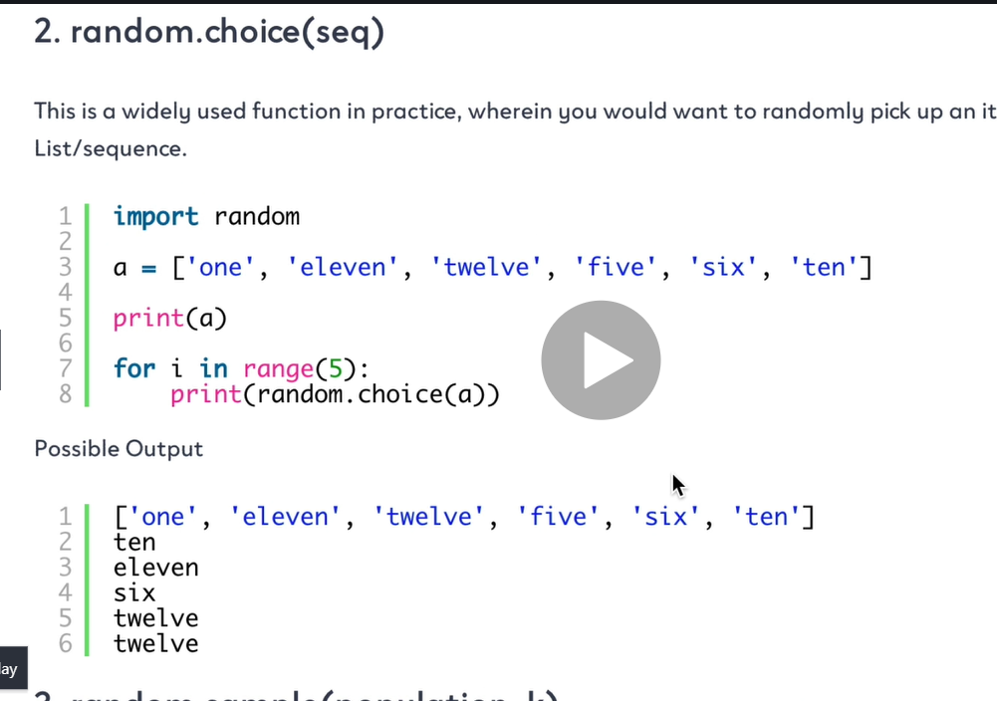

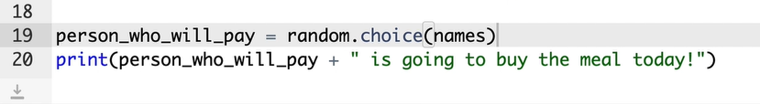

**IndexErrors and working with nested lists**

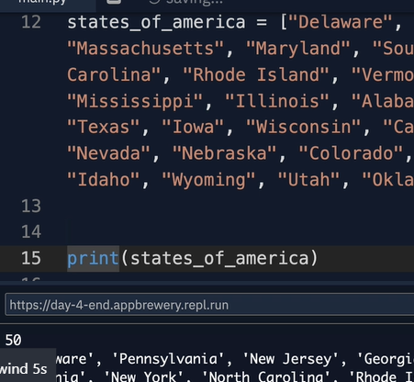

Index 50 doesn’t exist

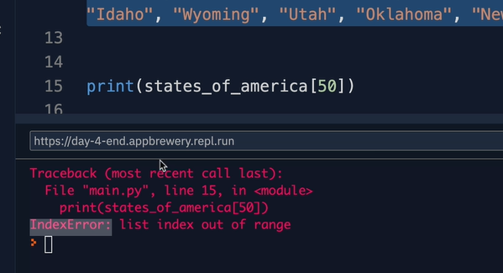

“list index out of range” - off by one a lot of times with lists.

Dirty dozen high pesticide produce 

inside some are fruits and some are vegetables 

Nested list 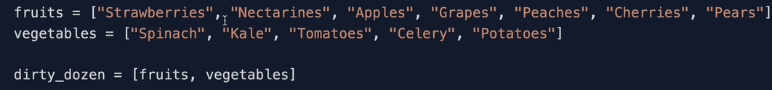

List of 2 lists



Treasure map

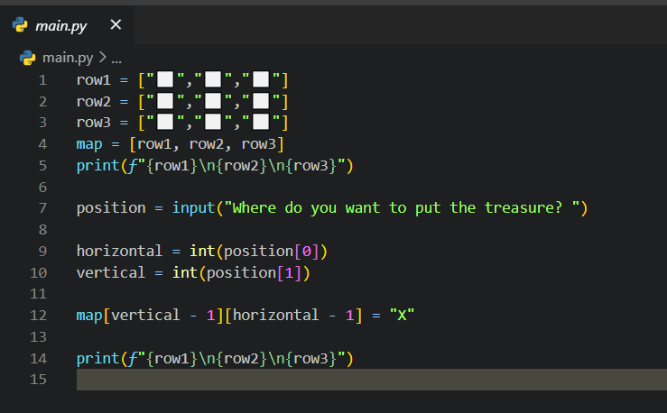

Rock Paper Scissors

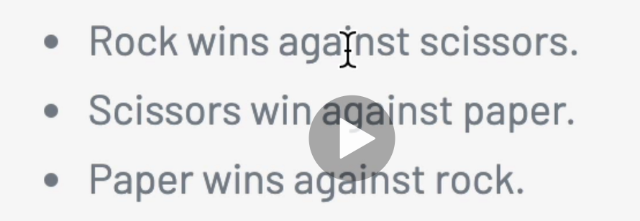

0